Modop Vega tool
Table of contents
Importation du visuel 1
Les bases de l’initialisation de la solution 5
Paramétrage du visuel 13
Paramétrage de la matrice des rectangles 13
Paramétrage de la matrice des Jalons 14
Paramétrage des couleurs 14
Paramétrage de la taille des formes 15
Les paramètres du visuel 16

To use this visualization solution, you must have already imported and cleaned your data.

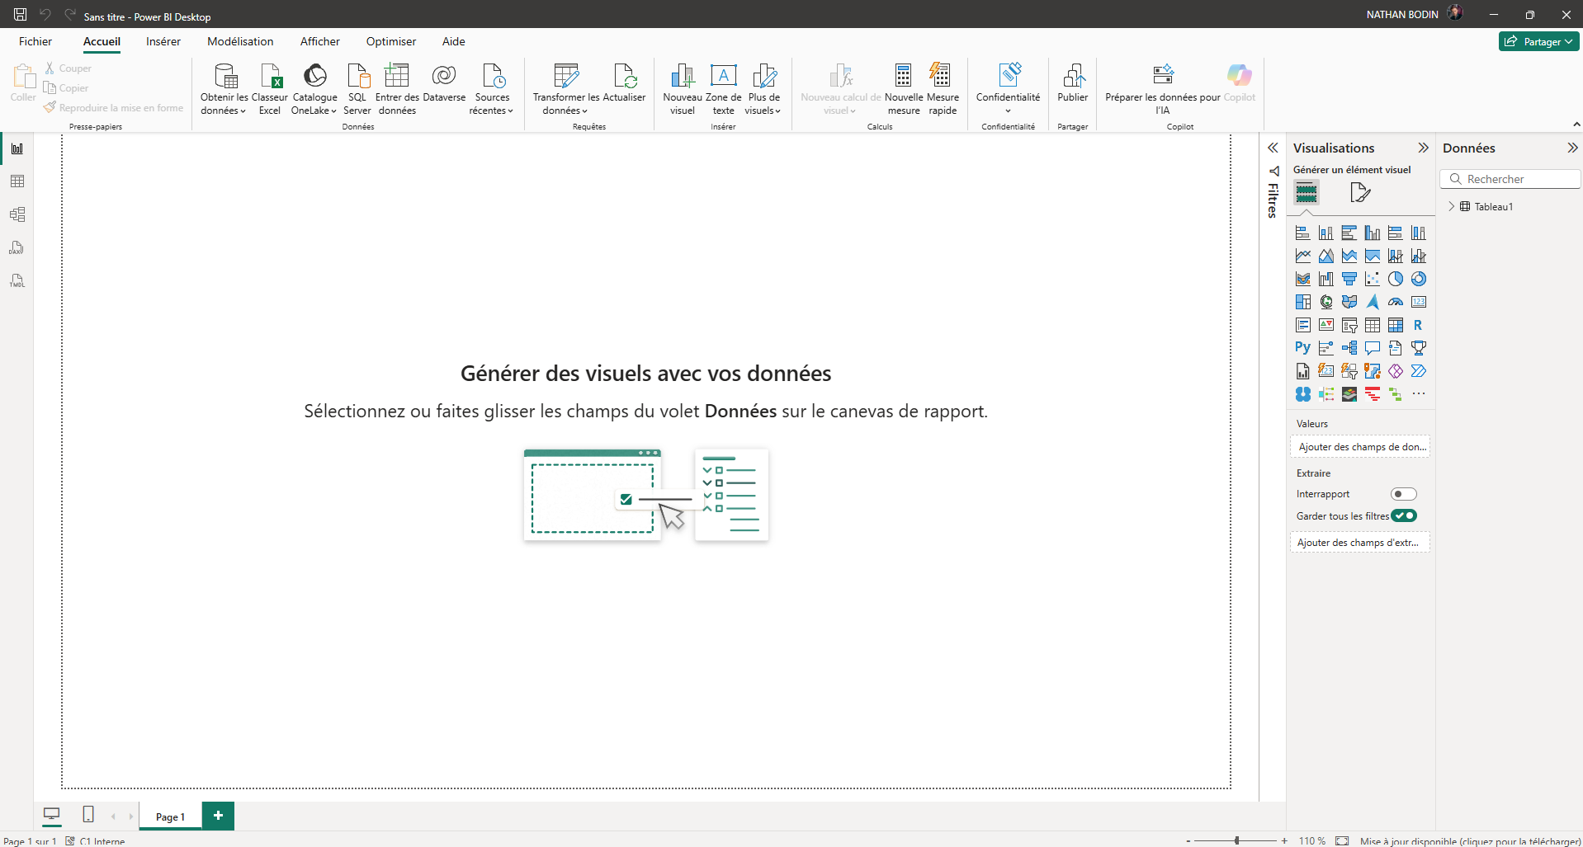
Importing the visual
1

This is what you see when you arrive at Power BI.
- Click on the « … » (1)
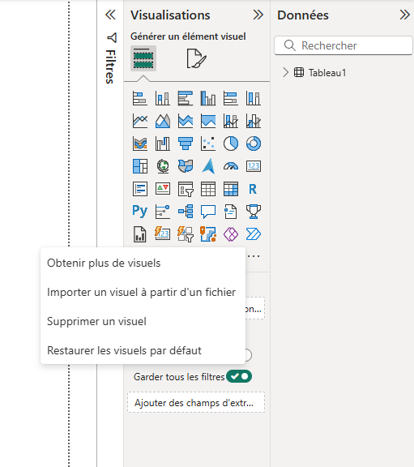
2

- Then click on « Obtenir plus de visuels » or « Obtain more visuals » (2)
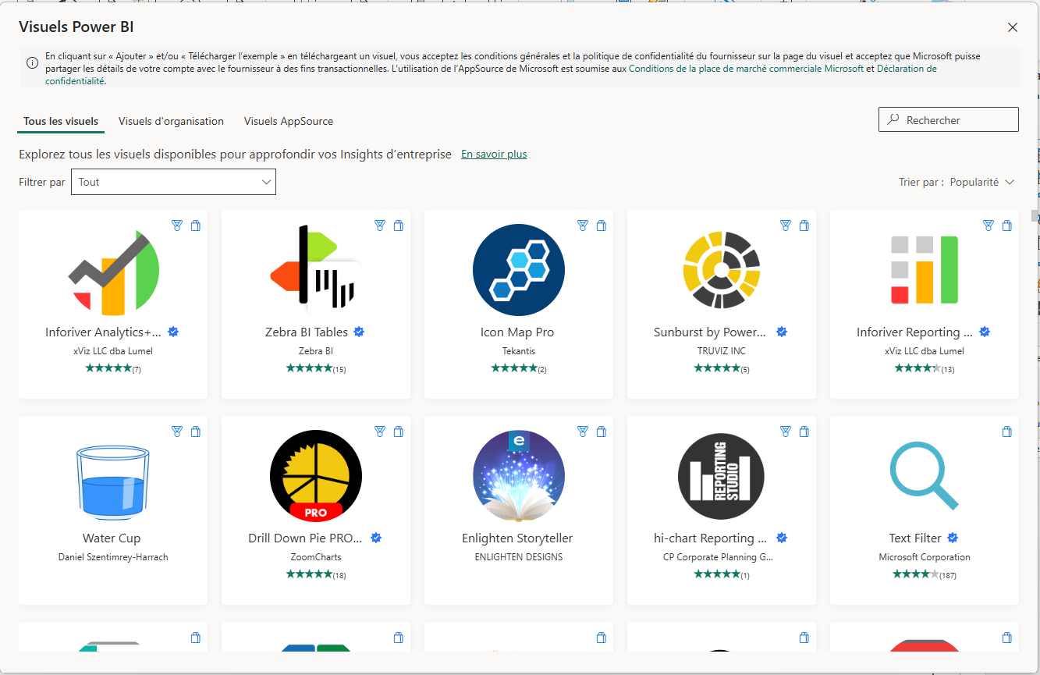
3
You have arrived at this page.
- On the search bar (3) write « Deneb » (it’s the support of the solution).
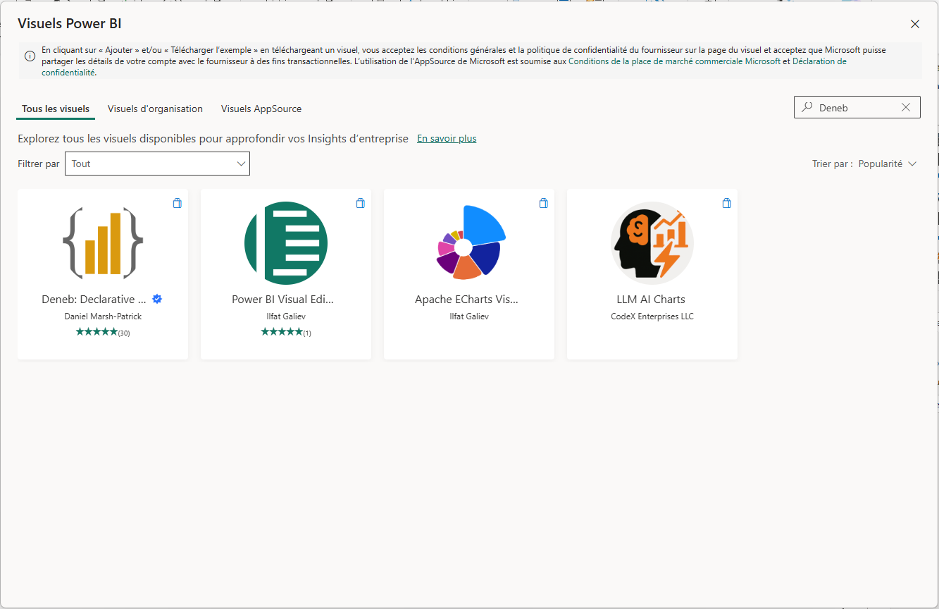
4
- Then click on the image « Deneb : Declarative… » (4)
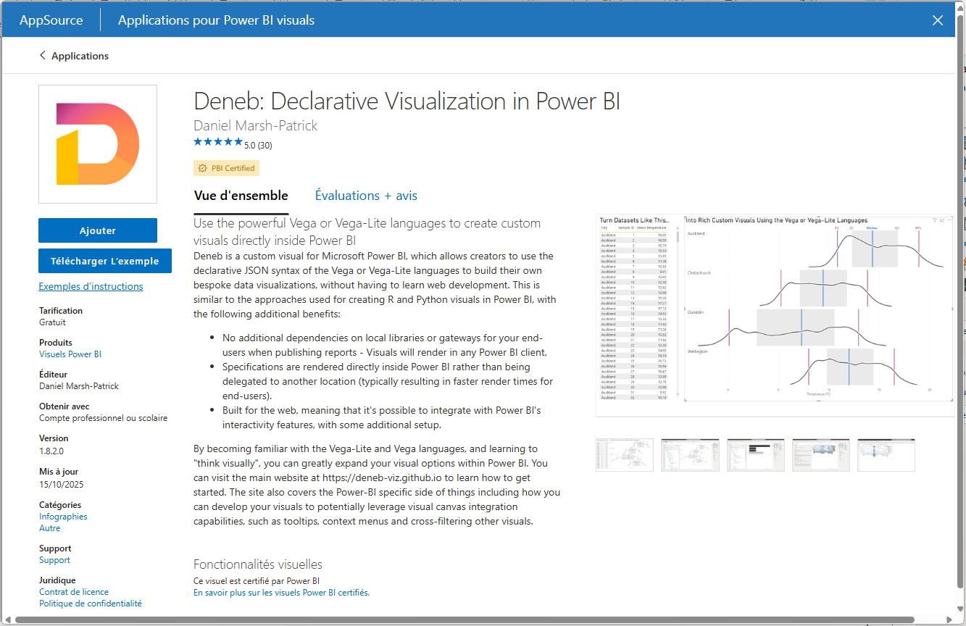
5
- Click on « Ajouter » or « Add » (5)

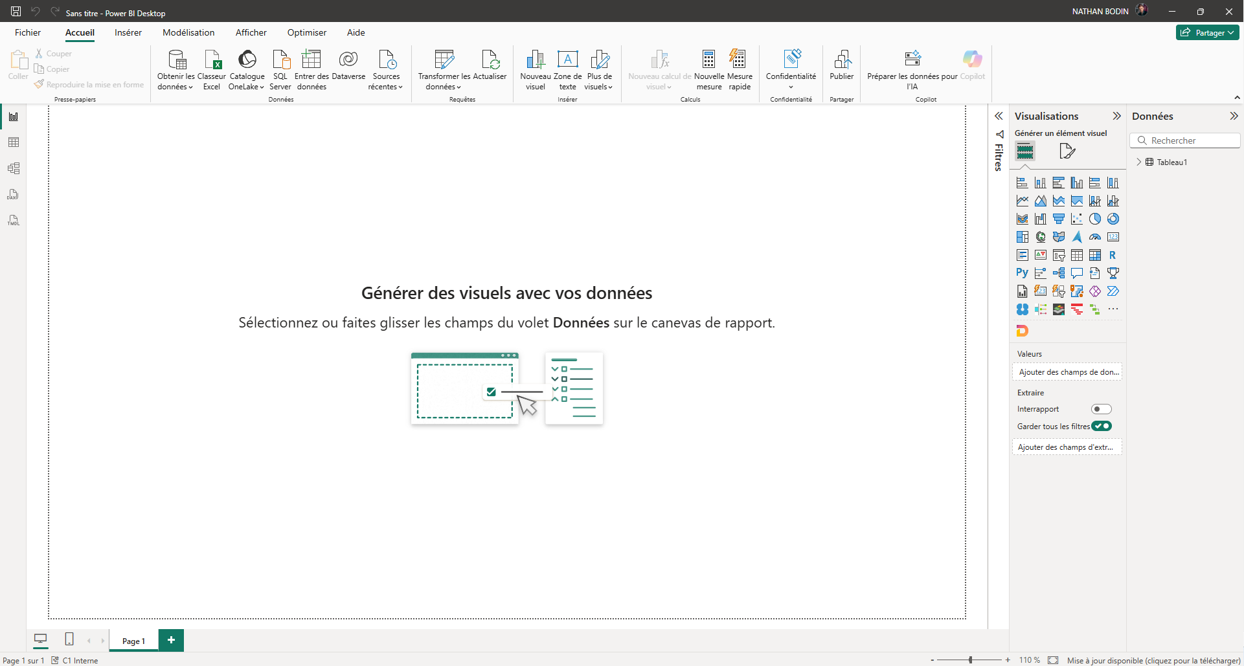
6
A new visual has just appeared (6)
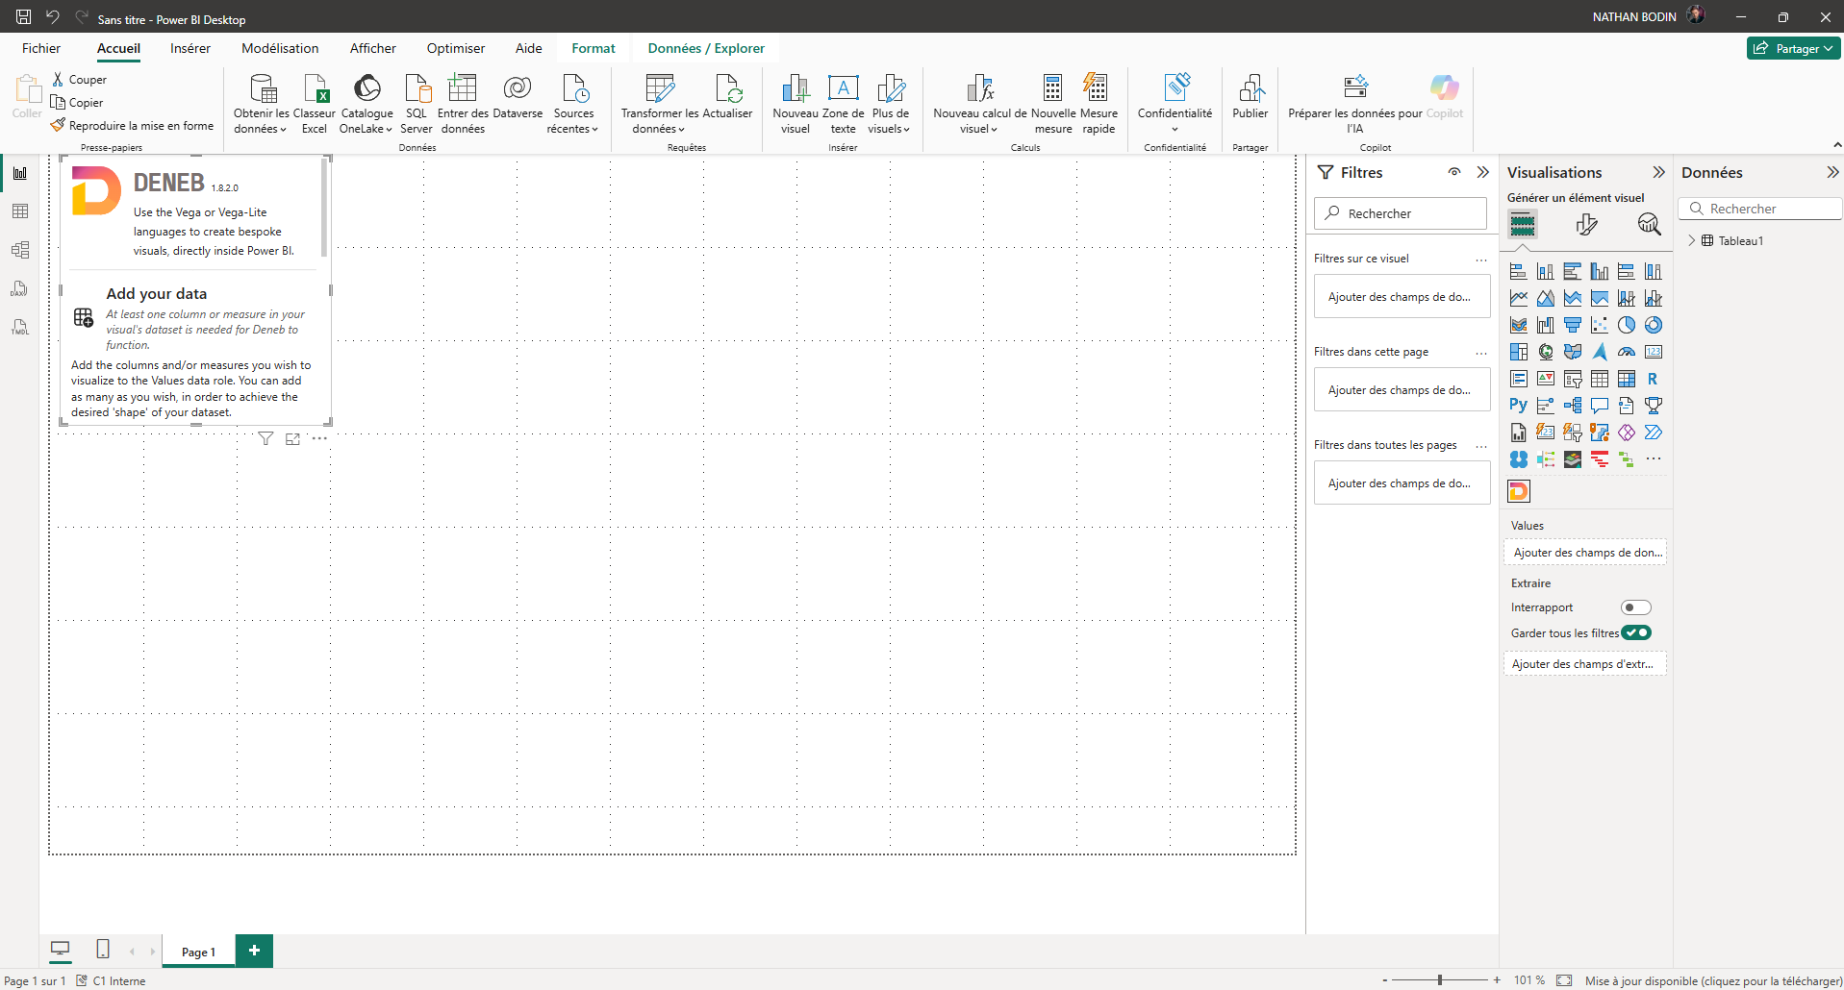
- Click on this new visual (6)
7

A new window has just appeared (7). You can enlarge it if you wish. You have just imported the Deneb visual which will support the visualization solution.

The basics of initializing the solution
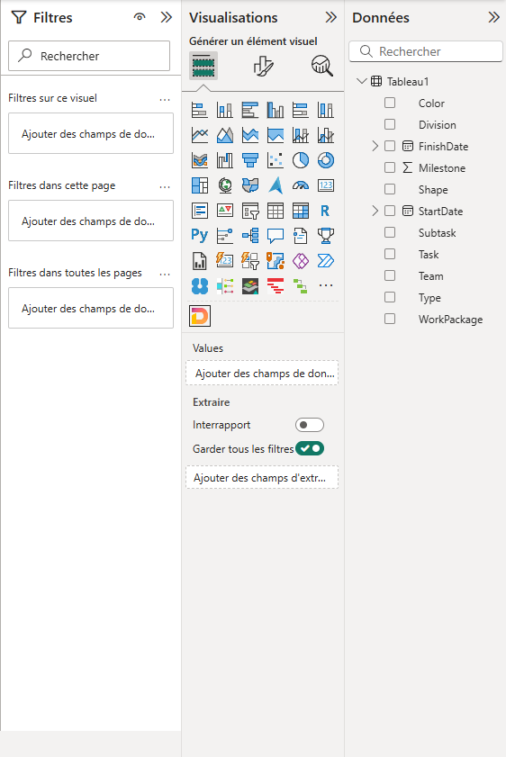
8
On the right side of Power BI you can see the columns of your data (8).
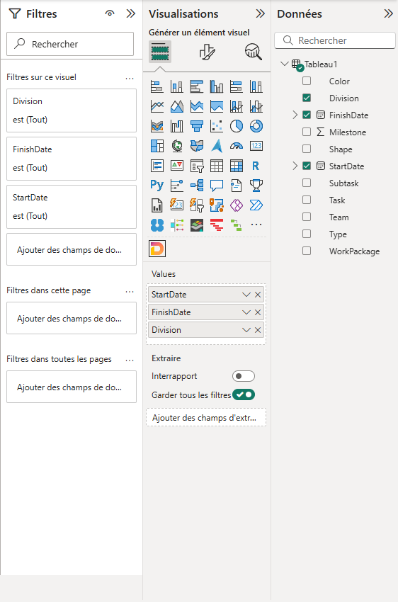
10
9
- Select the data you want to view (9). These column names will also be displayed in "Values" (10), if so then everything is good.
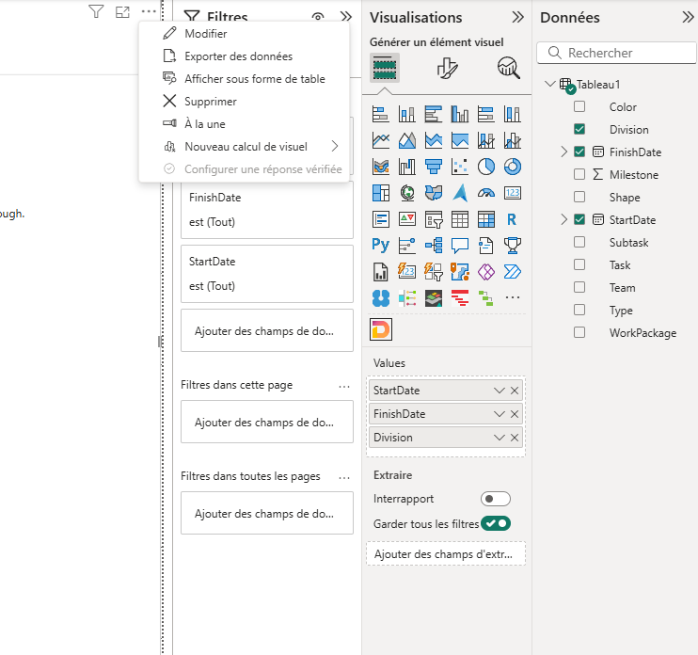
11
- Once you have selected your columns, click on the "…" (11) and then on « Modifier » or « Edit » (11).
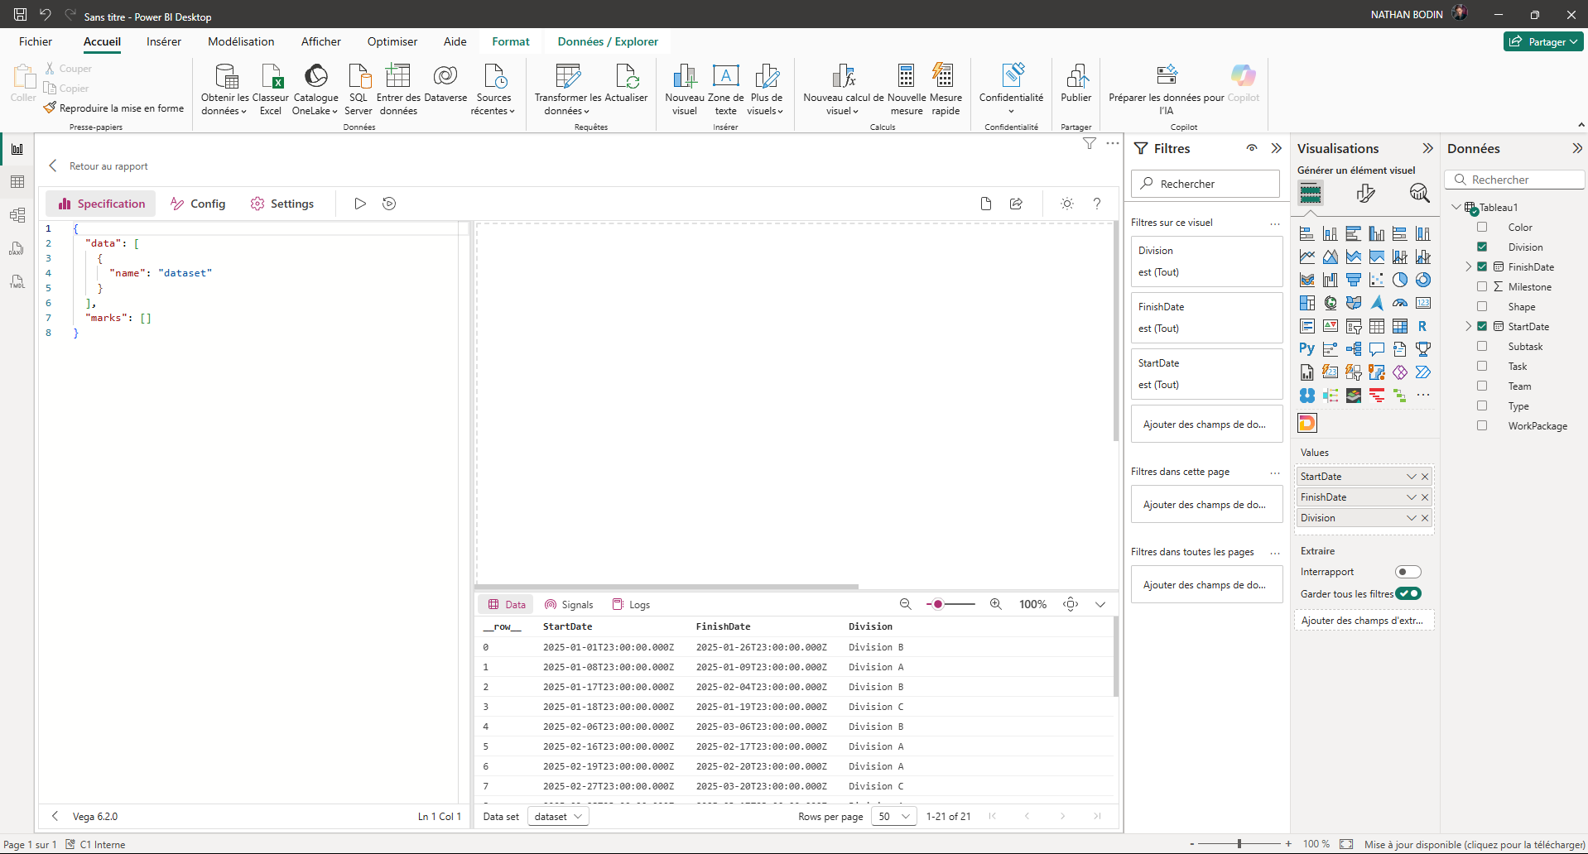
13
12
Once this is done, this window will open. On the left (12) you will find the code section, the data section (13) below the visual, and the visual section in the center.
- Delete the few lines of code in (13) and then copy and paste the solution code.
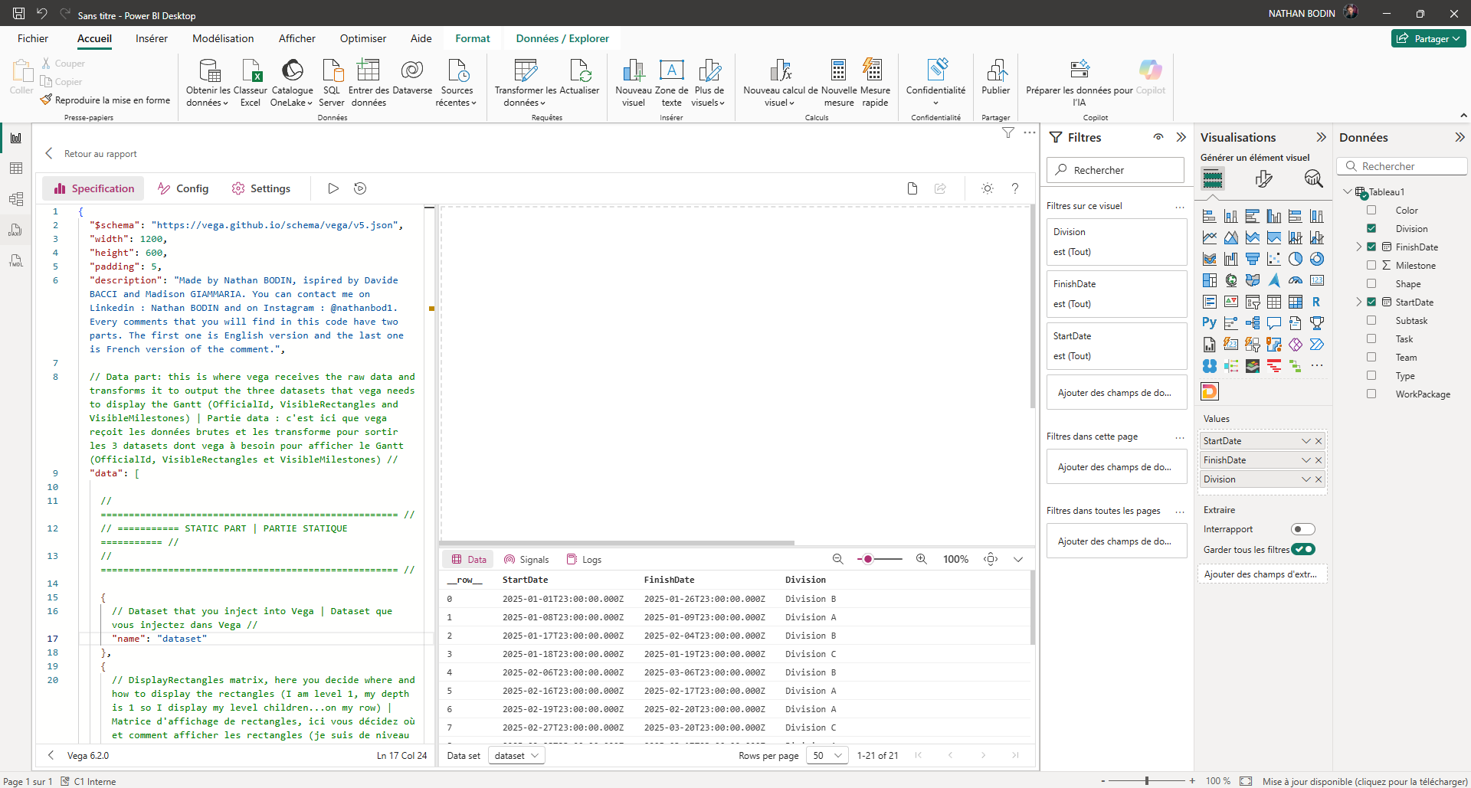
14
The code is now in the visual
- Click on « Config » (14)
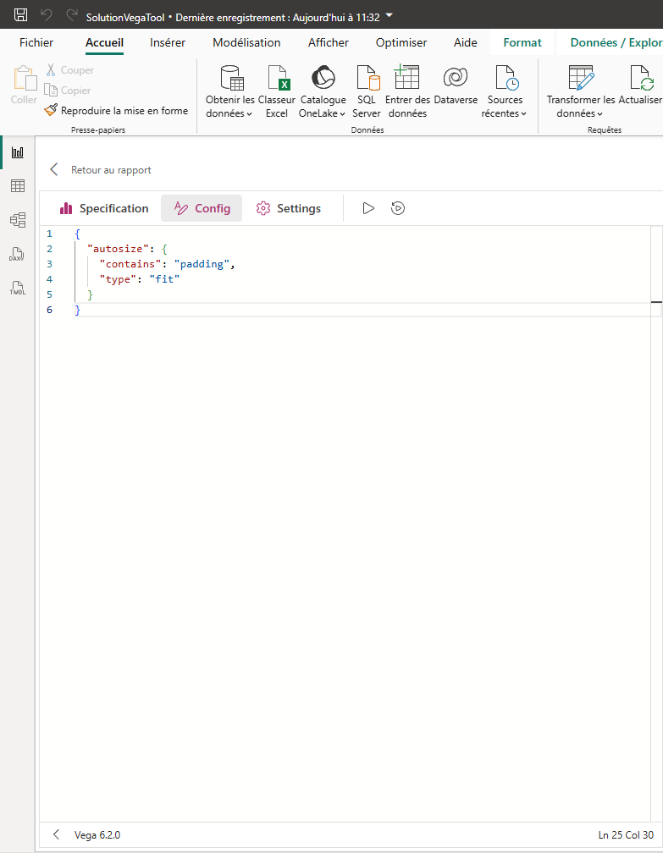
- Delete this code
15
- Go back to « Specification »
- Then press « run » (15)
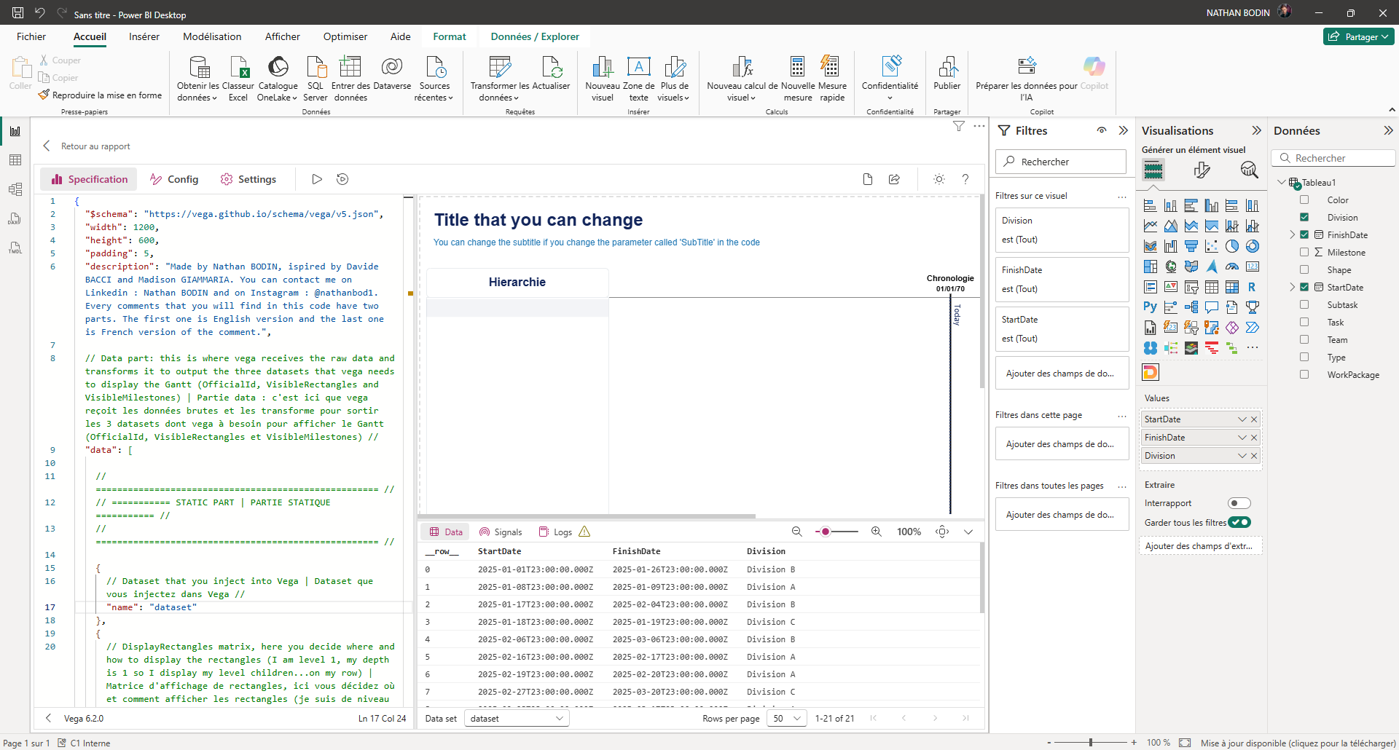 Nothing is displayed at the moment and that's normal because we haven't done the mapping (renaming the column so that the visualization solution understands what you want).
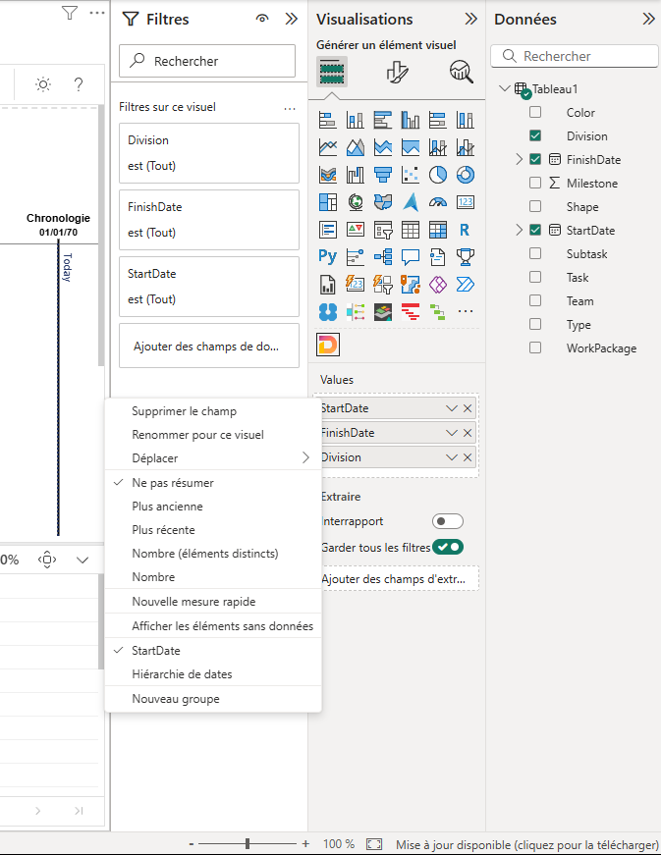
16
Then, rename the columns :
- Right-click on one of your columns in the "Values" section (16)
- Then « Renommer pour ce visuel » or « Rename for this visual »(16)
Respect this mapping :
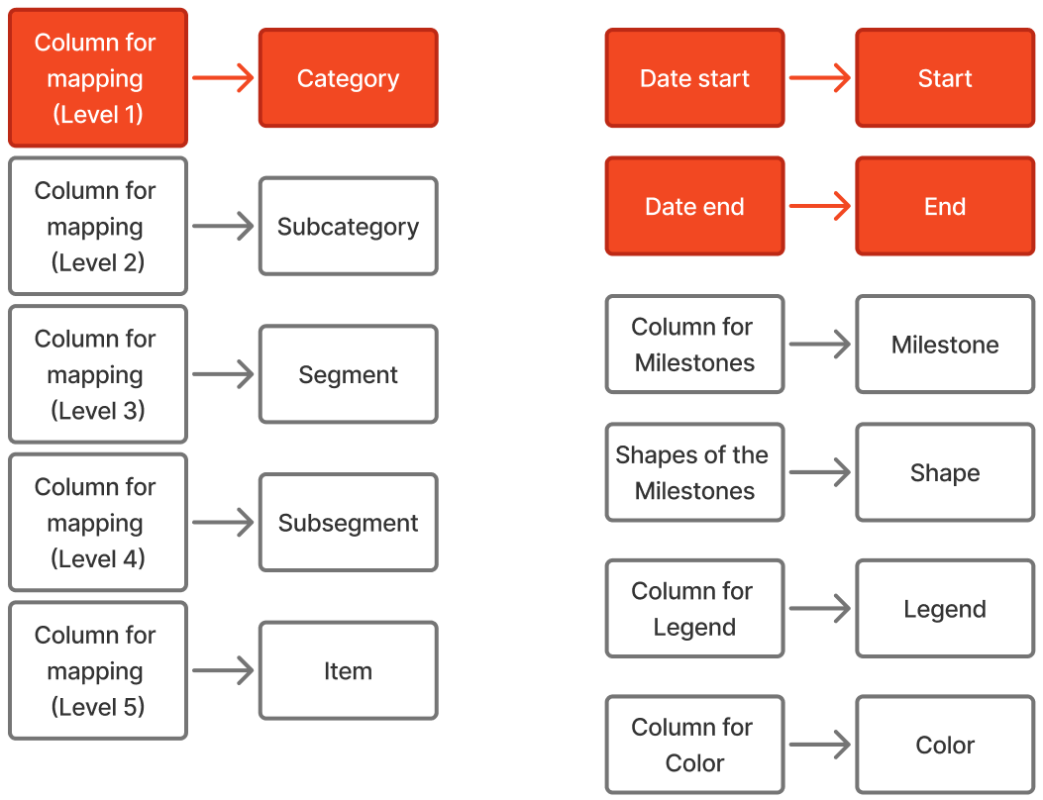
The elements in red are mandatory (these are the 3 columns I included in the example above). This visualization is a hierarchical Gantt chart, meaning you must specify the desired hierarchy in the code. Here is the hierarchy:
Category > Subcategory > Segment > Subsegment > Item.
Be sure to follow this order.
The Start and End columns are date columns that will be used to position the elements on the Gantt chart.
You can also add Milestones (which you will rename). A Milestone must be a column of 0 or 1 (1 meaning that this row is a Milestone).
Then, using the "Shape" column, you can define the shape of each of these Milestones. Here are the possible shapes:
circle :
square :
cross :
diamond :
triangle-up :
triangle-down : …
triangle-left : …
triangle-right : …
wedge :
arrow :
You can also import your own shapes via an SVG path. This gives you an infinite number of possible shapes.
The Legend column ensures that rows with the same Legend are color-coded. If you want to use your own colors, you can specify them in the Color column (in hexadecimal or English). Alternatively, if you don't have a Color column, you can define a color for a Legend in the code.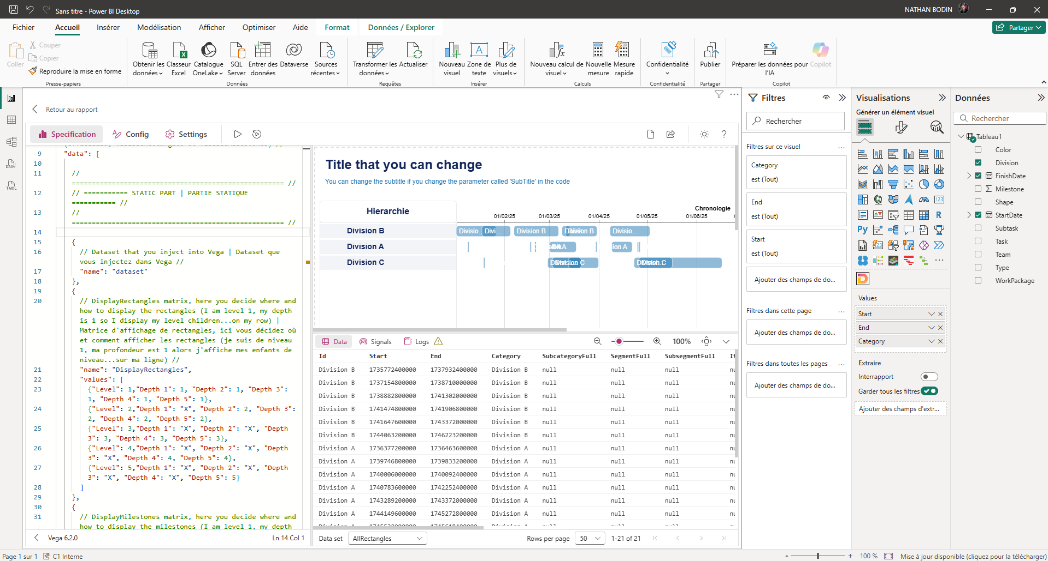
Here is the result if you only included the 3 required columns.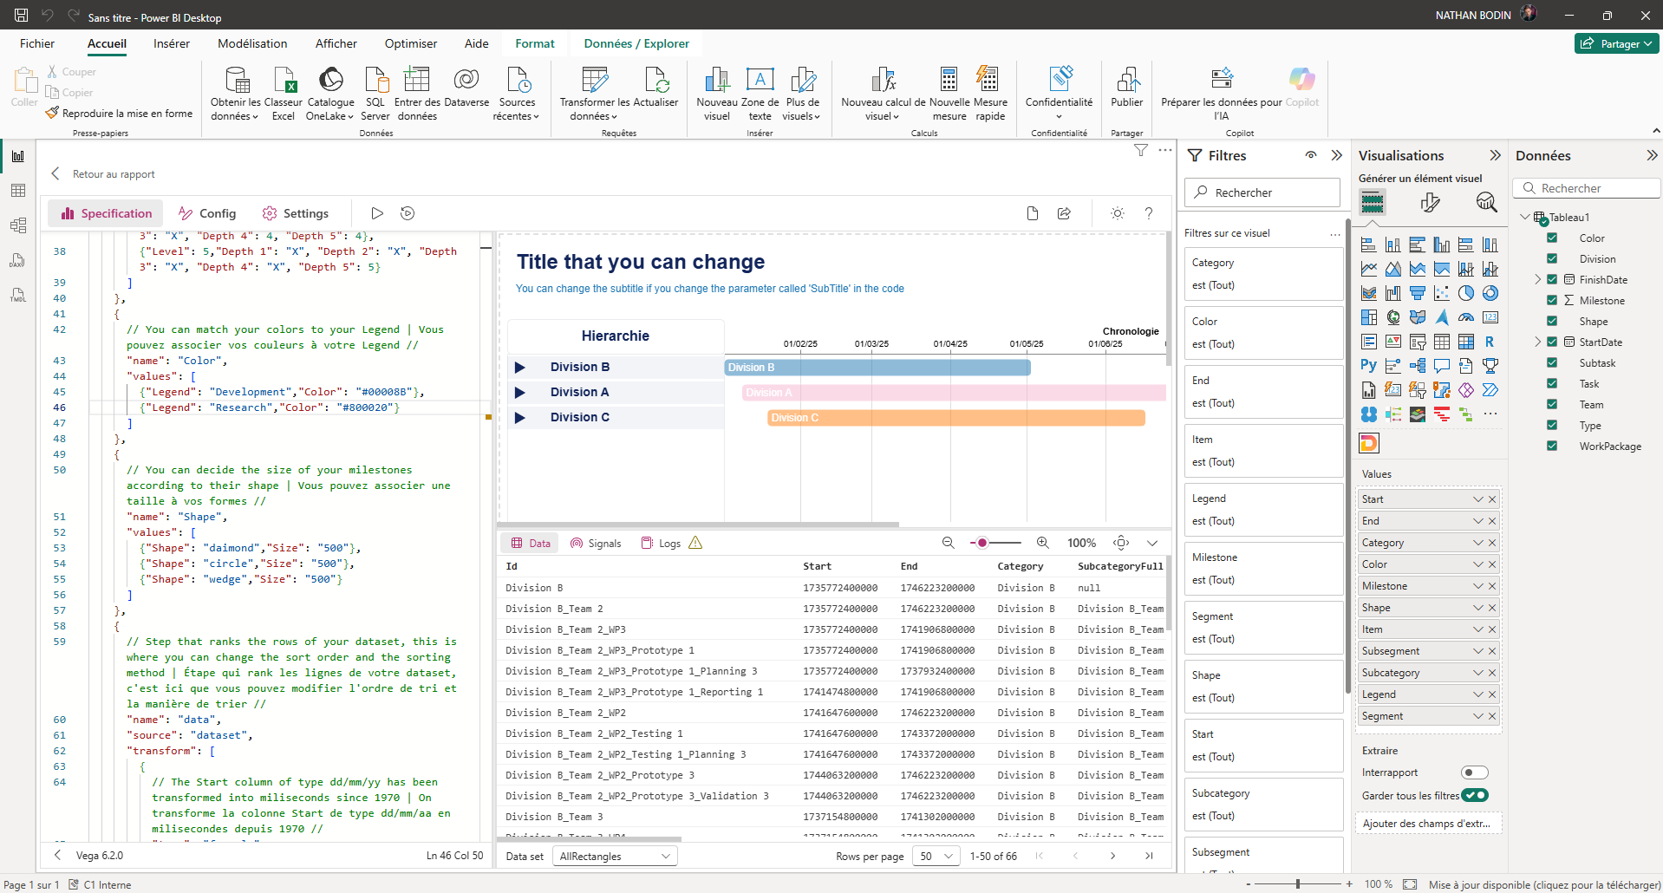

Here's the result if you've filled in all the columns. But it's not finished yet; to get the look you want, you need to configure it correctly.

Visual Configuration

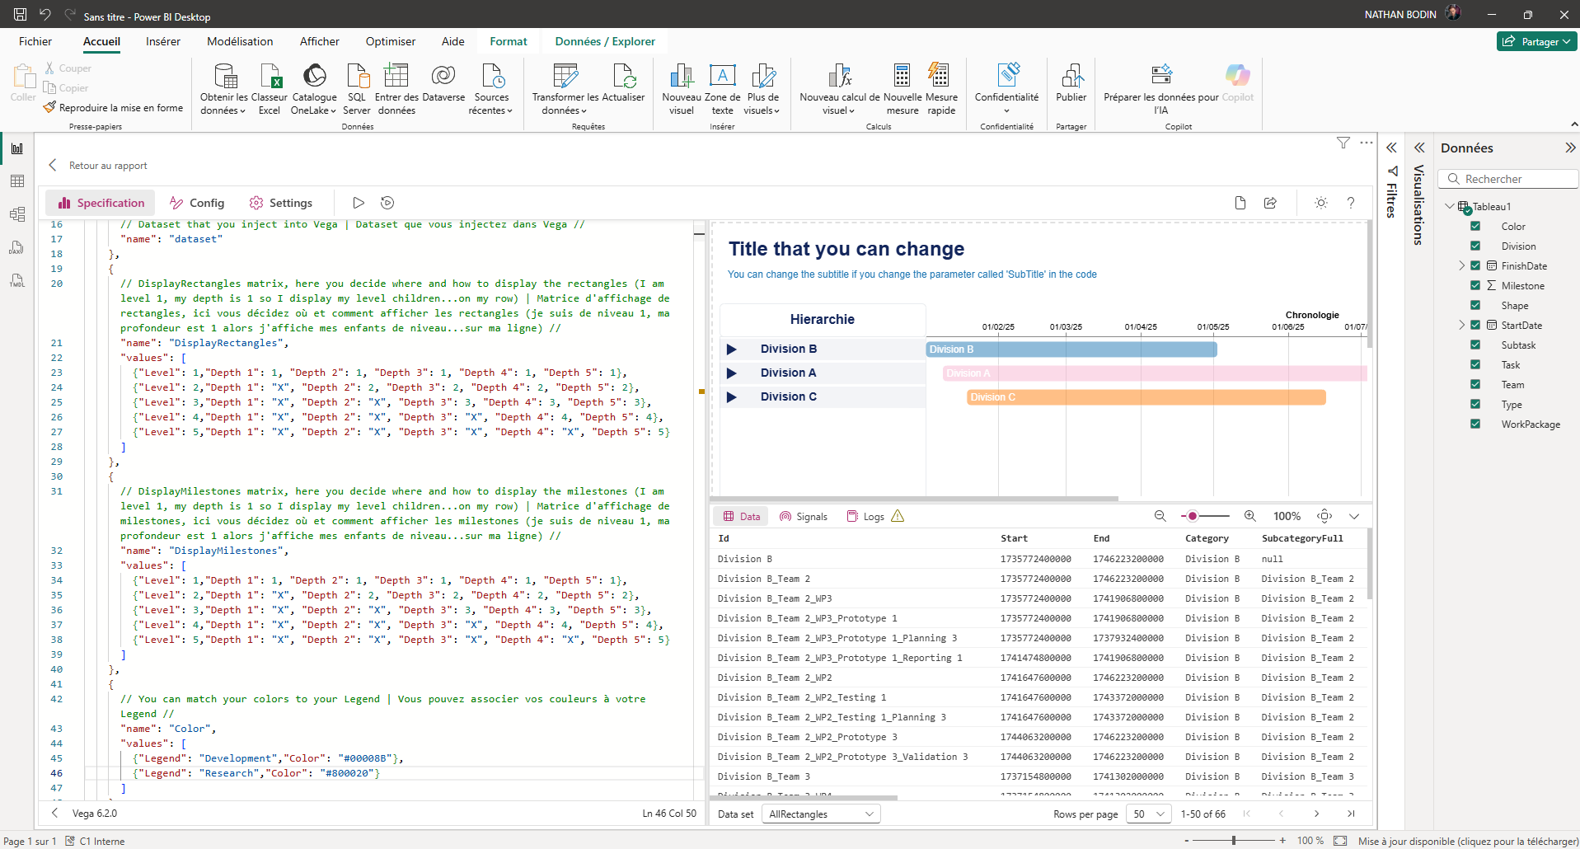
Setting up the rectangle matrix
17

- In "DisplayRectangles" (17) you can modify the values ​​of this matrix. For example, on the level 1 row, you can decide that regardless of the Gantt chart's development, level 5 children will move to the level 1 row by placing 5s throughout the row. Then run "run".
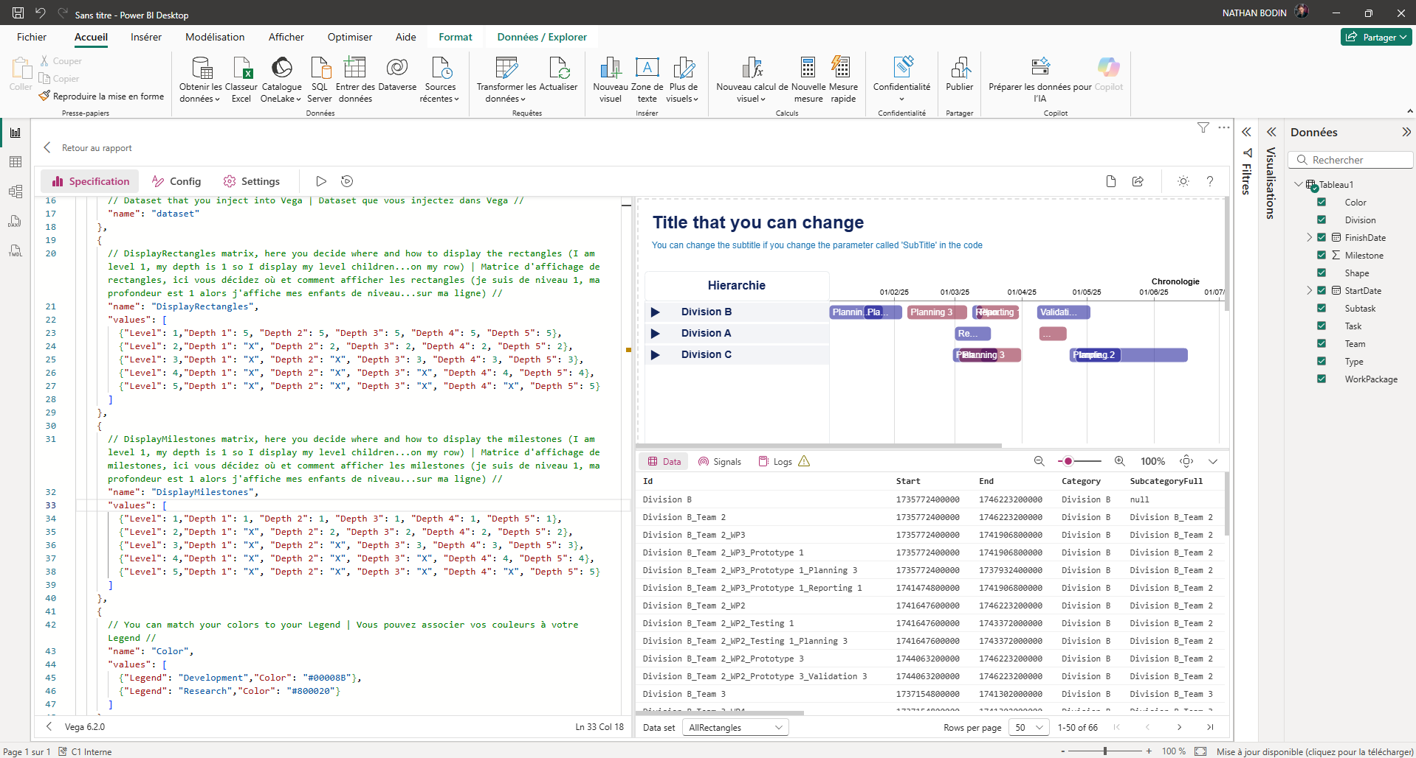
19
18
Here is the result

Setting up the Milestone Matrix
- In “DisplayMilestones” (18) you can modify the values ​​of this matrix. Its operation is similar to the previous matrix, but this matrix manages the behavior of the Milestones. Therefore, the Milestones are independent of the rectangles.

Color settings
- If you haven't entered a color column, you can enter the color associated with each Legend in the "Color" table (19). Otherwise, the solution will find colors for you.

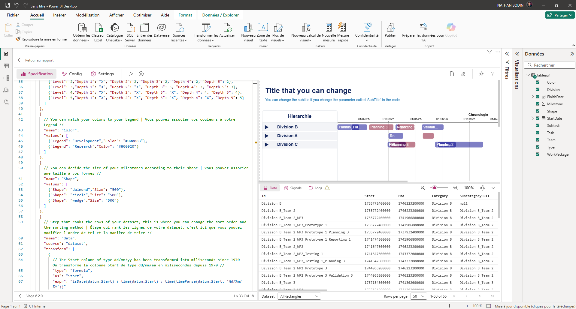
Setting the size of the shapes
20

- In the "Shape" table (20) you can decide the size of each shape according to the nature of the shape. Otherwise, the default size is 500.

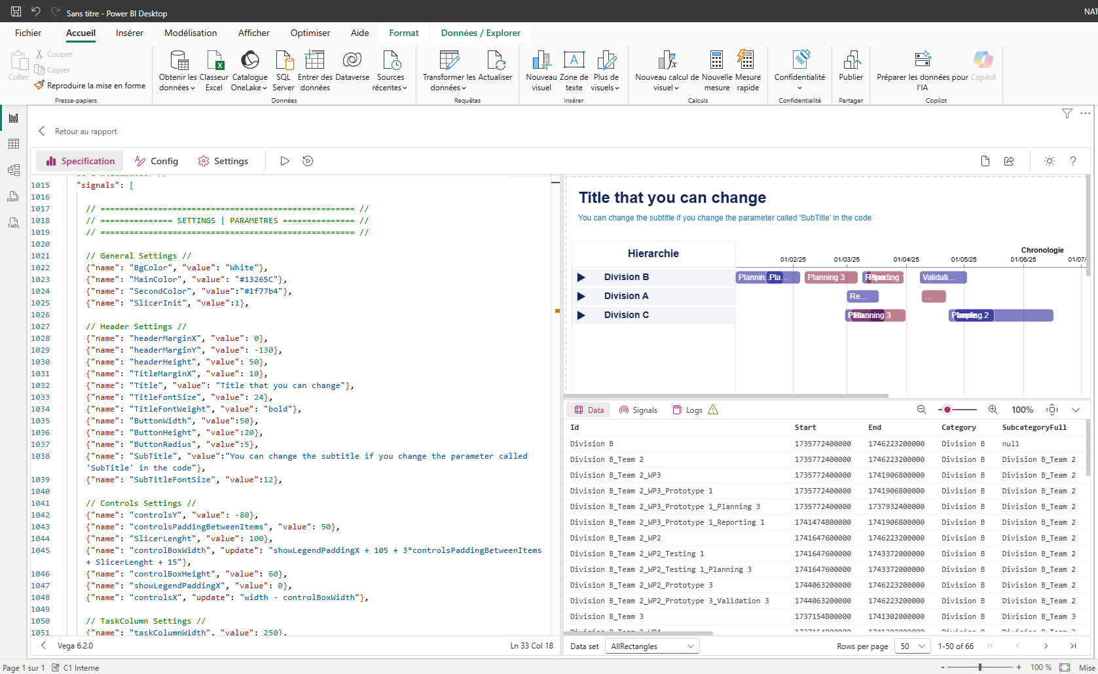
Visual settings
21

- You can modify almost anything you want. To do this, go to the code and scroll down to line 1000 where you will see "SETTINGS" (21). You can modify any value of these parameters.

